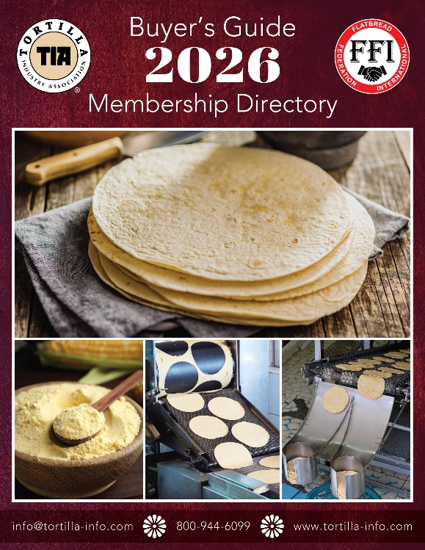
Ad Reservation Form

2026 TIA MEMBERSHIP DIRECTORY AND BUYER’S GUIDE!
This directory is an indispensable tool for anyone involved in our industry. Don’t miss out on an entire year’s exposure and the opportunity to stand out from your competition by advertising or enhancing your company’s listing!
BOTH PRODUCERS AND SUPPLIERS CAN
NOW ADVERTISE!

*** DEADLINE: January 15th 2026 ***

(Note: Update Forms Due by Dec 15)

Advertising Rates:
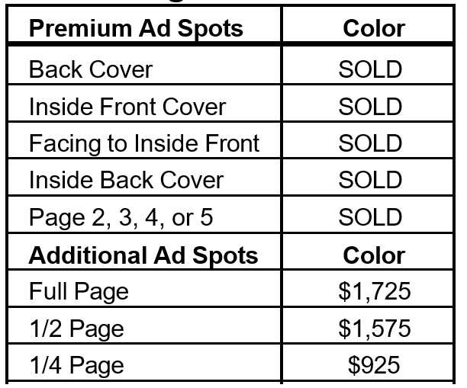

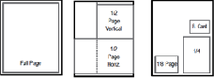

Enhanced Listing | Price
Boxed Listing | $ 150
Boxed Listing with Logo | $ 205
Boxed Listing with Logo & 50 word bio | $ 295

Pay By Check: Make payable to: Tortilla Industry Association
and mail to: TIA, 1400 North 14th Street, Arlington VA 22209

Pay by Credit Card:
Scan and email to terri@tortilla-info.com

Credit card #
8.5” x 11” Publication (U.S. “letter” size)

Complete and email to: terri@tortilla-info.com
Please fill/type out information below and include ad size from table at left. TIA will send you the required ad contract, along with ad creation information.
Company: Contact: Phone: Fax: Email: Ad Size: Color B&W

Amount Authorized Exp Date Signature Date
Tortilla Industry Association- 1400 North 14th Street, Arlington VA 22209 – www.tortilla-info.com
If you have any questions or to reserve ad space, please contact Terri Owens at terri@tortilla-info.com Or Call 800-944-6099 ext 2


